Hansard Top Tips

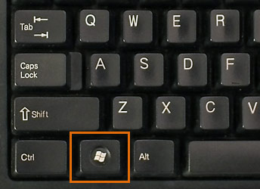

KEYBOARD SHORTCUTS

1 – Windows Key to open Start menu

2 – Windows Key + L = Lock computer

3 – Windows Key + M = Minimise all open screens
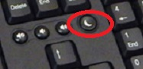
4 – Use the ‘crescent moon’ button to put your computer to sleep – move your mouse to wake it up again

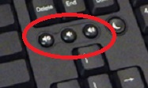
5 – Adjust sound quickly using one of the three ‘speaker’ buttons

6 – Use of CTRL key
- Ctrl + A to Select all text
- Ctrl + B to Bold selected text
- Ctrl + I to Italicise selected text
- Ctrl + C to Copy selected text
- Ctrl + X to Cut selected text
- Ctrl + V to Paste selected text
- Ctrl + Y to Redo
- Ctrl + Z to Undo
- Ctrl + S to Save
- Ctrl + P to get to Print
- Ctrl + Home to go to beginning of document
- Ctrl + End to go to end of document
- Shift + Ctrl + End to select all
- Ctrl + Esc to open Start menu

7 – Keyboard accents on ‘foreign’ words– for example:
è = Alt + 0232
é = Alt + 0233
ê = Alt + 0234
ñ = Alt + 0241
ë = Alt + 0235
* See Appendix 1 for all accent codes

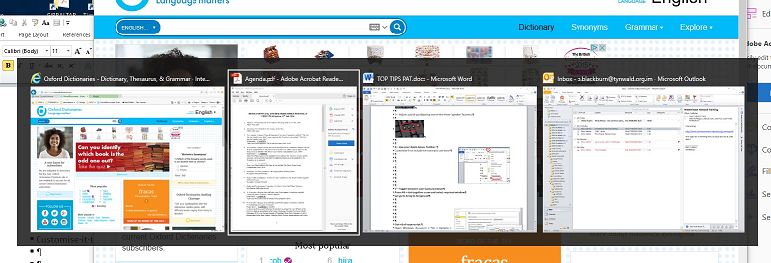
HOW TO …

1 –Toggle between open tasks/windows
Press Alt + tab together to see all your open windows; select required window; release keys to bring to foreground

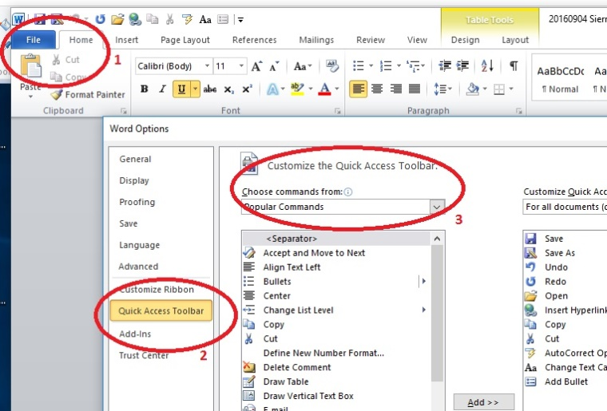
2 – Use your Quick Access Toolbar:
Go to Word>File>Options>Quick Access toolbar,
then customise it to include the icons you use most from the dropdown list – for example
- Save
- Save as
- Undo
- Redo
- Open
- Copy
- Paste
- Auto Correct
- Auto Text
- Change Text Case
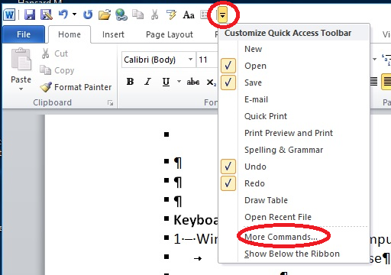

Or click on the arrow on the top left of your Word document –
see All Commands or More Commands and select your options from the list

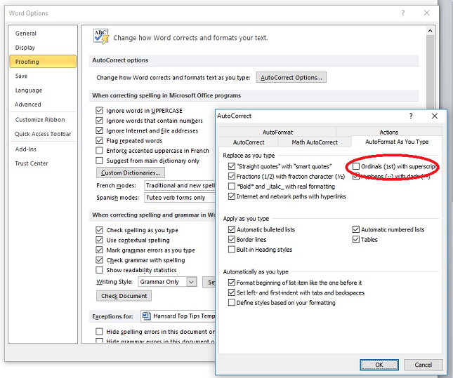

3 – Take off superscript:
Open Windows document>File>Options>Proofing> AutoCorrect options>Autocorrect as you type> untick Ordinals (1st) with superscript

WORD SHORTCUTS
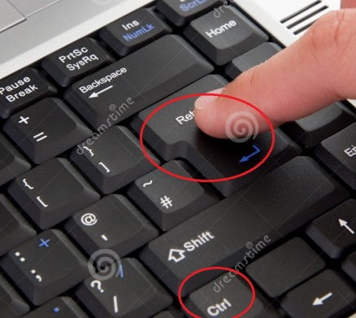
Page Break:
1 – Insert page break quickly by pressing Ctrl and Return/Enter together

2 – Change case, capitalise word:
- Click immediately to left of word, shift + F3 together – no need to highlight letter or word
- or click Aa on main toolbar or Quick Access toolbar

3 – Repeat your most recent action, for example formatting or deleting or typing press F4

4 – Open and access Save As by pressing F12

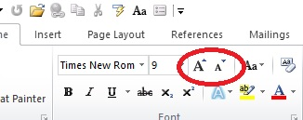
5 – Click AA symbols on toolbar to increase or decrease font size quickly

6 – Use Auto Correct:
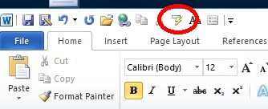
- Place Auto Correct on your Quick Access toolbar to correct or complete words or phrases as you type

Some Auto Correct examples:

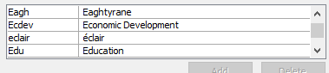
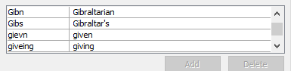
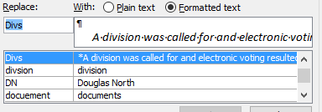
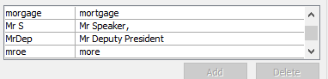
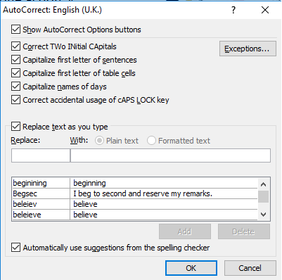

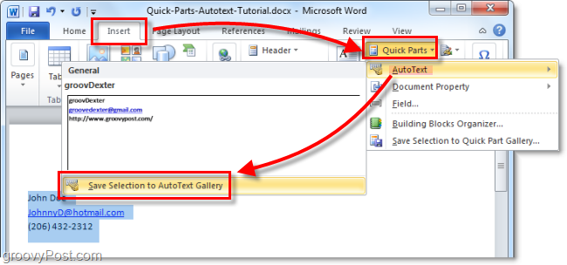
7 –Use Auto text:
To quickly access set pieces of text which you use frequently, set them up in AutoText
*Can be used in Word and Outlook, but lists need to be set up separately

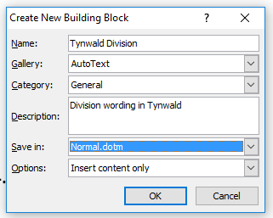

Open a document which includes the text then click Insert>Quick Parts>AutoText and Save Selection to AutoText Gallery – Name the text and describe it and click OK

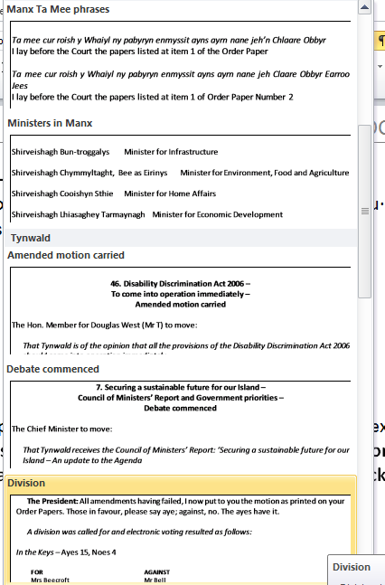

To use the text in a new document click AutoText on your Quick Access toolbar, select your required text and it will appear in your document

New in Word 2010 for AutoText
Start typing text that is contained in one of your AutoText entries and pop-up box will tell you to Press Enter to insert the Autotext entry.

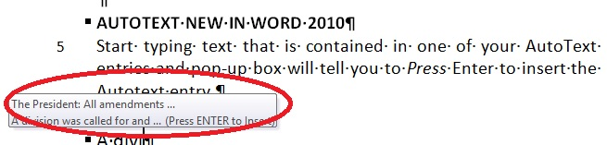

OR just type in the first couple of letters of an Autotext entry
and then press F3 to insert the most similar entry
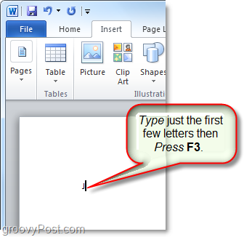

OUTLOOK SHORTCUTS
1 – To save emails:
- Drag and drop from Outlook into relevant folder, then re-name.
- For multiple emails, hold down Shift and click to highlight several consecutive emails, then drag & drop or Ctrl+C/Ctrl+V to Copy and Paste
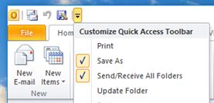
- or create a Save As shortcut button in the Quick Access Toolbar

2 – Use of CTRL key
- Ctrl + Shift + M to create a new message
- Ctrl + N to create a new message
- Ctrl + R to Reply
- Ctrl + F to Forward
- Ctrl + P to Print
- Ctrl + Shift + I to switch to Inbox

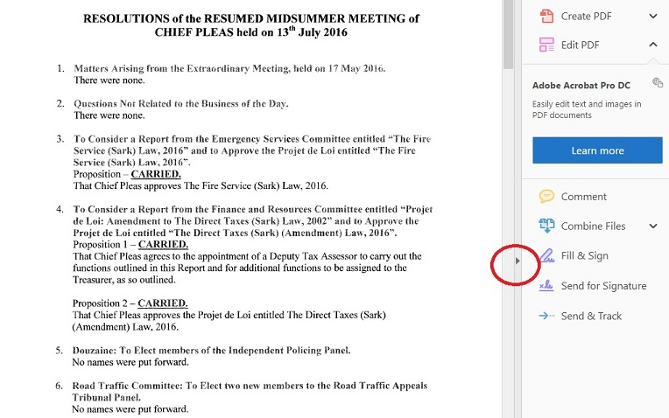

PDF HANDY SHORTCUT
1 – If your PDF document includes toolbar on the right, click centre arrow to hide toolbar so your document fills THE whole window

2 – You may be able to scan PDF documents and save them so you can select, copy, paste and edit to use in Word documents, rather than just saving as a jpeg image

APPENDIX 1
Keyboard Accent shortcuts

Windows Alt+ Codes for Accented Vowels
Accent | A | E | I | O | U | Y
Grave  Capital | À  0192 | È  0200 | Ì  0204 | Ò  0210 | Ù  0217
Grave Lower Case | à  0224 | è  0232 | ì  0236 | ò  0242 | ù  0249
Acute  Capital | Á  0193 | É  0201 | Í  0205 | Ó  0211 | Ú  0218 | Ý  0221
Acute Lower Case | á  0225 | é  0233 | í  0237 | ó  0243 | ú  0250 | ý  0253
Circumflex  Capital | Â  0194 | Ê  0202 | Î  0206 | Ô  0212 | Û  0219
Circumflex Lower Case | â  0226 | ê  0234 | î  0238 | ô  0244 | û  0251
Tilde  Capital | Ã  0195 | -- | Ñ  0209 | Õ  0213 | --
Tilde Lower Case | ã  0227 | -- | ñ  0241 | õ  0245 | --
Umlaut  Capital | Ä  0196 | Ë  0203 | Ï  0207 | Ö  0214 | Ü  0220 | Ÿ  0159
Umlaut Lower Case | ä  0228 | ë  0235 | ï  0239 | ö  0246 | ü  0252 | ÿ  0255

